*Imperial College of Engineering*

(RU Affiliated)

Lab Report

BSC Engineering 1st year 1st semester Examination ,2024

Course title: Computer Maintenance and Engineering Drawing

Course code: CSE1112

|  |  |
| --- | --- |
| **Submitted by:** | **Submitted to:** |
| **Name: Mst Ruhani Ishika** | **Aparna Haldar** |
| **Roll:23110** | **Lecturer, Department of Computer Science & Engineering** |
| **Session:2023-24** | **Imperial College of Engineering** |

Date: 05/10 /2024

# **INDEX**

|  |  |  |
| --- | --- | --- |
| **LAB NO** | **Content** | **Page** |
| 01 | Assemble different  parts of a computer | 3-6 |
| 02 | Install different types of application software and utilities software. |  |
| 03 | Install different types of Operating System such as Windows 10 |  |
| 04 | Partition a computer hard disk. |  |
| 05 | Fault findings Detect hardware related problems in CPU and fine the solution. |  |
| 06 | Getting familiar with DOS and its commands. |  |

**Lab: 1**

**Assembling different parts of a computer:**

* **Hard disk drive:**
* A hard disk drive (HDD) is a data storage device that uses spinning magnetic disks, called platters, to store and retrieve digital information. Data is accessed through a read/write head on an actuator arm, which moves across the spinning platters to read and write magnetic patterns organized into tracks and sectors. HDDs offer high storage capacity at a low cost per gigabyte, making them popular for desktops, laptops, and external storage, especially for applications that prioritize storage space over speed.
* **CPU (Central Processing Unit):**
* The Central Processing Unit (CPU) is the primary component of a computer that performs most of the processing inside a system. Often referred to as the "brain" of the computer, the CPU executes instructions from software by performing basic arithmetic, logical, control, and input/output operations. It consists of cores (individual processing units) that handle tasks simultaneously, with modern CPUs having multiple cores to improve multitasking and performance.
* **Motherboard:**
* The motherboard is the main circuit board of a computer, acting as the central hub that connects all components and allows them to communicate. It hosts the CPU, memory (RAM), storage devices, and expansion slots for graphics and other cards, as well as connectors for peripherals like USB devices. Power from the computer's power supply is distributed through the motherboard to various components, and it also houses the BIOS or UEFI firmware, which initializes hardware during startup. As the backbone of a computer system, the motherboard determines the compatibility and upgradeability of parts, influencing both the performance and functionality of the entire setup.

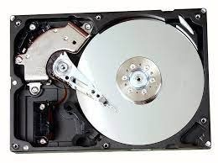

**Hard disk drive**

**Fig:01**

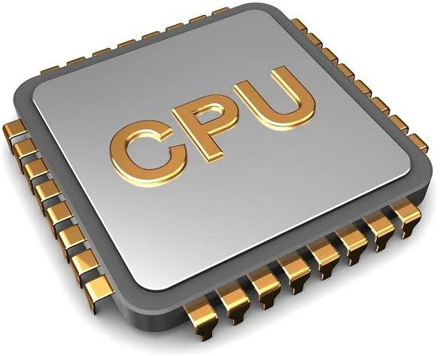

**Fig 02: CPU**

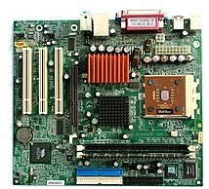 **Fig 03: Motherboard**

* **RAM (Random Access Memory) / ROM (Read-Only Memory):**
* RAM (Random Access Memory) and ROM (Read-Only Memory) are two essential types of memory in a computer, each serving different purposes. **RAM** is a volatile memory that temporarily stores data and instructions currently in use, allowing the CPU quick access to run programs and perform tasks efficiently. Since it’s temporary, all data in RAM is lost when the computer powers off. **ROM**, on the other hand, is non-volatile and permanently stores critical instructions needed for the computer to boot up, like the firmware (BIOS or UEFI).
* **CD/DVD (Optical Disc Drives):**
* CD and DVD drives, also known as optical disc drives, are devices used to read and write data on optical discs like CDs and DVDs. These drives use a laser to read data encoded as small pits on the disc’s surface, which represent digital information. CDs typically store up to 700 MB of data, while DVDs hold more, often up to 4.7 GB for a single layer, making DVDs suitable for larger media like video files
* **Keyboard:**
* The keyboard is an input device that allows users to enter text, commands, and data into the computer. It consists of keys for letters, numbers, and functions, enabling interaction with software applications.
* **Mouse:**
* The mouse is a pointing device that allows users to interact with the graphical user interface (GUI) by moving the cursor and clicking on elements. It enables easy navigation and control within software environments.

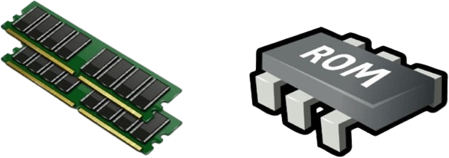

**RAM & ROM**

**Fig:04**

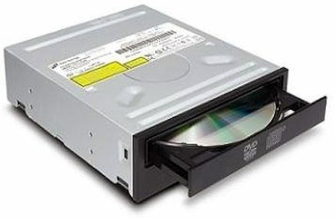

**Fig 05 :DVD**

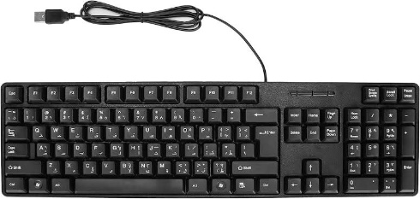

**Fig 06: Keyboard**

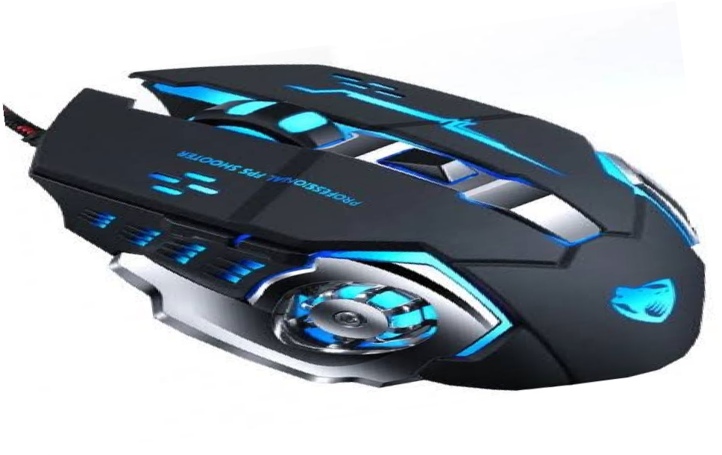

**Fig 07: Mouse**

* 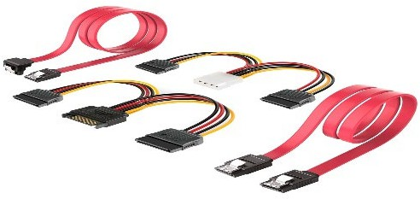**SATA Cable:**
* A SATA (Serial Advanced Technology Attachment) cable is used to connect storage devices like hard drives, solid-state drives, and optical drives to the motherboard, allowing data transfer within a computer. It consists of a narrow, flat cable with connectors on each end designed for easy installation and a secure fit.
* **USB Port:**
* A USB (Universal Serial Bus) port is a standard interface on computers and other electronic devices that allows for the connection and communication of peripherals such as keyboards, mice, printers, external storage devices, and more. USB ports facilitate both data transfer and power supply, enabling devices to exchange information and charge simultaneously.
* **Input Device:**
* Input devices are hardware that allow users to provide data and commands to the computer, such as keyboards, mice, scanners, and microphones. They enable interaction between the user and the computer system.
* **Output Device:**
* An output device is a hardware component that conveys information from a computer to the user or another device, translating digital data into a format that is understandable. Common examples of output devices include monitors, which display visual information; printers, which produce physical copies of documents and images; and speakers, which convert audio signals into sound.

**Fig 08:** **SATA Cable**

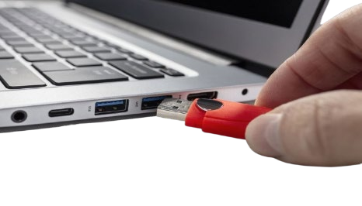

**Fig 09: USB Port**

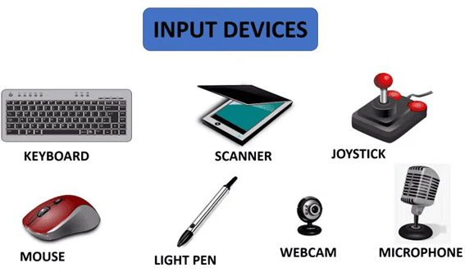

**Fig 10: Input device**

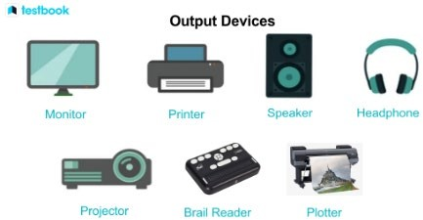

**Fig 11: Output device**

* 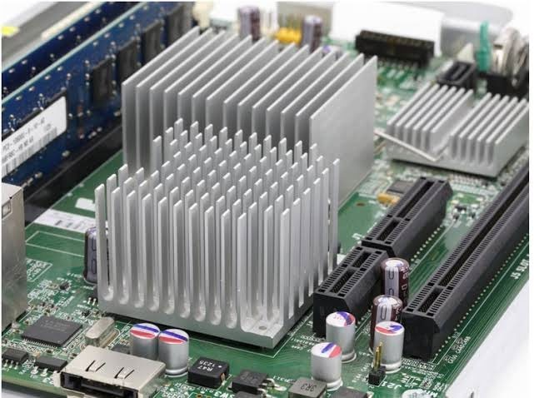**Heat Sink:**
* A heat sink is a device attached to components like the CPU or GPU to dissipate excess heat generated during operation, helping to maintain safe operating temperatures. Typically made from metals with high thermal conductivity, such as aluminum or copper, the heat sink transfers heat away from the component through direct contact.
* **Power Supply:**
* The power supply unit (PSU) is a critical component in a computer that converts electricity from an outlet into usable power for the computer's internal components. It takes alternating current (AC) from the wall and transforms it into the direct current (DC) required by the motherboard, CPU, hard drives, graphics card, and other parts. The PSU also regulates voltage to prevent power fluctuations that could damage components.
* **Cooling Fan:**
* A cooling fan is a crucial component in a computer that helps regulate the temperature of internal components by promoting airflow and dissipating heat. Typically mounted on the CPU heat sink, the case, or the power supply, these fans draw cooler air from the environment into the system and expel hot air, preventing overheating during operation. Cooling fans come in various sizes and speeds, with some designed for specific components, while others are used to enhance overall case ventilation.

**Source:-** [**https://www.google.com/search?q=Assembling+different+parts+of+a+computer+with+image&sca_esv**](https://www.google.com/search?q=Assembling+different+parts+of+a+computer+with+image&sca_esv)

[**https://chatgpt.com/c/6705488e-3034-8005-9f27-cf5fd55d5fa8**](https://chatgpt.com/c/6705488e-3034-8005-9f27-cf5fd55d5fa8)

**Fig 12: Heat sink**

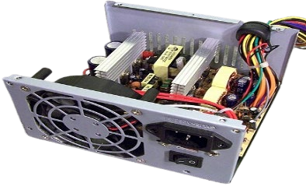

**Fig 13: Power supply**

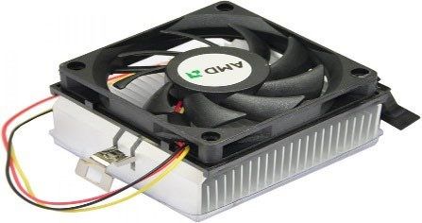

**Fig 14: Cooling fan**